|  |
| --- |
| Hippo Balloon Games inc. |
| External Game Document |
| THREEjs Web Game |
| All work Copyright © 2016 by Hippo Balloon Games.  All rights reserved. |
| **Nikita Chernykh, Ga-alo Omar, Eunmi Han** |
|  |

|  |
| --- |
| Apr 1th 2016 |

**Table of Contents**

Version History

Game Overview

Game Play Mechanics

Camera

Controls

Saving and Loading

Interface Sketch

Menu and Screen Descriptions

Game World

Levels

Game Progression

Characters

Non-player Characters

Enemies

Weapons

Items

Abilities

Vehicles

Script

Scoring

Puzzles/Mini-games

Bonuses

Cheat Codes

Sound Index

Story Index

Art / Multimedia Index

Design Notes

Future Features

## 

## Version History

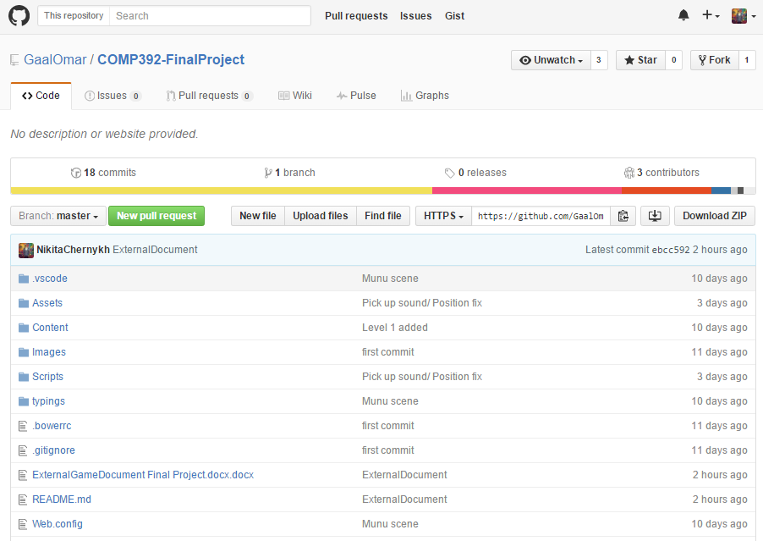

## Game Overview

You are in candyland where your goal is to collect all the donuts you see on your way home.

## Game Play Mechanics

Game mechanics are simple:

* Move left, right, forward, back
* Jump

## Camera

Game is first person view, you see what camera sees.

## Controls

Game uses a keyboard to control the player.

* Move with: A, W, S, D
* Jump with SPACE
* Mouse to look around

## Saving and Loading

Game will load the assets before start, saving will be optional.

## Interface Sketch

Level3

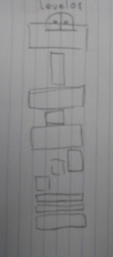

Level2

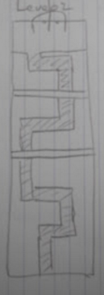

Level3

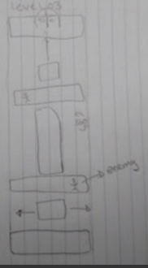

## Menu and Screen Descriptions

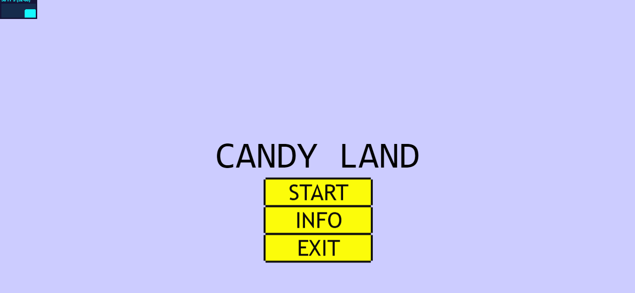

## Game World

Game world is a basic 3D cubical world.

## Levels

Game will have three levels, but with different environment and challenges

Level1

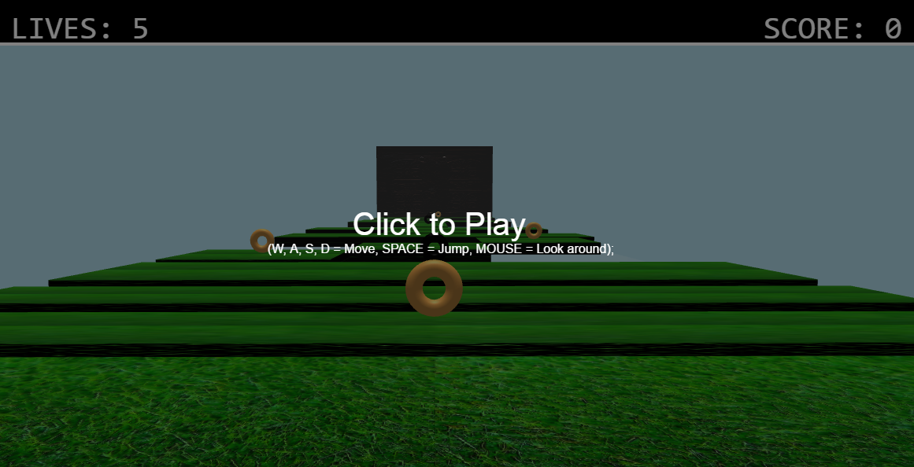

Level2

goes here

Level3

## Game Progression

Game difficulty will increase by using more difficult obstacles towards the end of the game and during its progress. New levels will introduce new mechanics so player can learn and adjust.

## Characters

Main player is you and it is up to your imagination how you picture yourself.

## Non-player Characters

Ghosts

## Enemies

There will be no enemies in the game, but it will have hazards:

* Gaps
* Ugly donuts
* Lava blocks
* Poison rivers
* Ghosts

## Weapons

None

## Items

Items in the game will be donuts. This is the main collectible to increase you score in the game.

## Abilities

Only ability player have is move and jump.

## Vehicles

Not Applicable

## Script

TBA

## Scoring

Game will have a score which is a count of donuts that player collects. Player will have 5 lives to get to his home. If player loses them all - it’s game over.

## Puzzles/Mini-games

N/A

## Bonuses

N/A

## Cheat Codes

Optional in the near future

## Sound Index

* Jump sound
* Land sound

## Story Index

You live in a candyland where you need eat donuts to survive.

As always the player goes on an adventure to get more donuts, but don’t get it confused about candyland. It maybe sweet but not an easy world.

## Art / Multimedia Index

Donut:

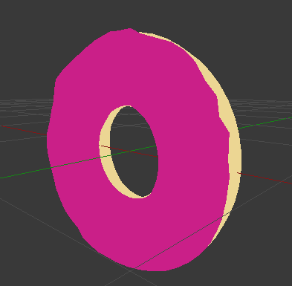

## Design Notes

*(Include additional design notes here)*

## Future Features

*(Include any future features that are planned to be implemented)*